***SOLUTION*** ***Section* 3.2 – Infinite Series**

***Exercise***

Find the limit of the following sequences or determine the limit does not exist 

***Solution***







***Exercise***

Find the limit of the following sequences or determine the limit does not exist 

***Solution***









 ***Using L’Hôpital’s rule***







***Exercise***

Find the limit of the following sequences or determine the limit does not exist 

***Solution***





***Exercise***

Find the limit of the following sequences or determine the limit does not exist 

***Solution***





***Exercise***

Find the limit of the following sequences or determine the limit does not exist 

***Solution***





***Exercise***

Find the limit of the following sequences or determine the limit does not exist 

***Solution***







 ***Using L’Hôpital’s rule***









***Exercise***

Find the limit of the following sequences or determine the limit does not exist 

***Solution***





 ***Using L’Hôpital’s rule***













***Exercise***

Find the limit of the following sequences or determine the limit does not exist 

***Solution***

 ***Using L’Hôpital’s rule***





***Exercise***

Find the limit of the following sequences or determine the limit does not exist 

***Solution***

 





***Exercise***

Find the limit of the following sequences or determine the limit does not exist 

***Solution***













***Exercise***

Find the limit of the following sequences or determine the limit does not exist 

***Solution***





***Exercise***

Find the limit of the following sequences or determine the limit does not exist 

***Solution***









***Exercise***

Find the limit of the following sequences or determine the limit does not exist 

***Solution***



















***Exercise***

Find the limit of the following sequences or determine the limit does not exist 

***Solution***



















***Exercise***

Find the limit of the following sequences or determine the limit does not exist 

***Solution***









***Exercise***

Find the limit of the following sequences or determine the limit does not exist 

***Solution***











***Exercise***

Find the limit of the following sequences or determine the limit does not exist 

***Solution***

The series  oscillates

Therefore; there is ***no limit***.

***Exercise***

Find the limit of the following sequences or determine the limit does not exist 

***Solution***







Using Gemeometric series Test 

Therefore; the given sequence  ***diverges***.

***Exercise***

Find the limit of the following sequences or determine the limit does not exist 

***Solution***







***Exercise***

Find a formula for the *n*th term partial sum of the series and use it to find the series’ sum if the series converges 

***Solution***









***Exercise***

Find a formula for the *n*th term partial sum of the series and use it to find the series’ sum if the series converges 

***Solution***





 









***Exercise***

Find a formula for the *n*th term partial sum of the series and use it to find the series’ sum if the series converges 

***Solution***



The series ***diverges***

***Exercise***

Find a formula for the *n*th term partial sum of the series and use it to find the series’ sum if the series converges 

***Solution***





 



***Exercise***

Find a formula for the *n*th term partial sum of the series and use it to find the series’ sum if the series converges 

***Solution***





 



***Exercise***

Write out the first few terms of each series to show how the series starts. Then find the sum of the series



***Solution***



The sum of geometric series: 

***Exercise***

Write out the first few terms of each series to show how the series starts. Then find the sum of the series



***Solution***



The sum of geometric series: 

***Exercise***

Write out the first few terms of each series to show how the series starts. Then find the sum of the series



***Solution***



The sum of geometric series: 

***Exercise***

Write out the first few terms of each series to show how the series starts. Then find the sum of the series



***Solution***





The sum of geometric series: 



***Exercise***

Determine if the geometric series converges or diverges. If a series converges, find its sum



***Solution***



⇒ The series is geometric ***converges*** to 

***Exercise***

Determine if the geometric series converges or diverges. If a series converges, find its sum



***Solution***



⇒ The series is geometric and ***diverges***.

***Exercise***

Determine if the geometric series converges or diverges. If a series converges, find its sum



***Solution***

The series is geometric with 

***Converges*** to 

***Exercise***

Express each of the numbers as the ratio of two integers (fraction) 

***Solution***











***Exercise***

Express each of the numbers as the ratio of two integers (fraction) 

***Solution***









***Exercise***

Express each of the numbers as the ratio of two integers (fraction) 

***Solution***











***Exercise***

Express each of the numbers as the ratio of two integers (fraction) 

***Solution***

















***Exercise***

Determine if the series converges or diverges. Give reasons for your answers. If a series converges, find its sum. 

***Solution***

Geometric series ***converges***: 





***Exercise***

Use Divergence to determine if the series converges or diverges. 

***Solution***







By the divergence Test, the given series ***diverges***.

***Exercise***

Use Divergence to determine if the series converges or diverges. 

***Solution***







By the divergence Test, the given series ***inconclusive***.

***Exercise***

Use Divergence to determine if the series converges or diverges. 

***Solution***











By the divergence Test, the given series ***diverges***.

***Exercise***

Use Divergence to determine if the series converges or diverges. 

***Solution***











By the divergence Test, the given series ***inconclusive***.

***Exercise***

Use Divergence to determine if the series converges or diverges. 

***Solution***







By the divergence Test, the given series ***inconclusive***.

***Exercise***

Use Divergence to determine if the series converges or diverges. 

***Solution***







By the divergence Test, the given series ***diverges***.

***Exercise***

Use Divergence to determine if the series converges or diverges. 

***Solution***







By the divergence Test, the given series ***diverges***.

***Exercise***

Determine if the series converges or diverges. Give reasons for your answers. If a series converges, find its sum. 

***Solution***





***Exercise***

Determine if the series converges or diverges. Give reasons for your answers. If a series converges, find its sum. 

***Solution***



It is geometric series ***converges*** with sum 

***Exercise***

Determine if the series converges or diverges. Give reasons for your answers. If a series converges, find its sum. 

***Solution***



⇒ It is geometric series ***converges*** with sum 

***Exercise***

Determine if the series converges or diverges. Give reasons for your answers. If a series converges, find its sum. 

***Solution***





***Exercise***

Determine if the series converges or diverges. Give reasons for your answers. If a series converges, find its sum. 

***Solution***









***Exercise***

Determine if the series converges or diverges. Give reasons for your answers. If a series converges, find its sum. 

***Solution***





 ***Both are geometric series.***







***Exercise***

Determine if the series converges or diverges. Give reasons for your answers. If a series converges, find its sum. 

***Solution***

 

The geometric series ***diverges***

***Exercise***

Determine if the series converges or diverges. Give reasons for your answers. If a series converges, find its sum. 

***Solution***

This geometric series: 

The geometric series ***diverges***

***Exercise***

Determine if the series converges or diverges. Give reasons for your answers. If a series converges, find its sum. 

***Solution***

This geometric series: 

The geometric series ***diverges***

***Exercise***

Determine if the series converges or diverges. Give reasons for your answers. If a series converges, find its sum. 

***Solution***



The series ***diverges***

***Exercise***

Determine if the series converges or diverges. Give reasons for your answers. If a series converges, find its sum. 

***Solution***



The series ***diverges***

***Exercise***

Determine if the series converges or diverges. Give reasons for your answers. If a series converges, find its sum. 

***Solution***









The series ***converges***

***Exercise***

Determine if the series converges or diverges. Give reasons for your answers. If a series converges, find its sum. 

***Solution***







The series ***converges***

***Exercise***

Determine if the series converges or diverges. Give reasons for your answers. If a series converges, find its sum. 

***Solution***









The series ***diverges***

***Exercise***

Determine if the series converges or diverges. Give reasons for your answers. If a series converges, find its sum. 

***Solution***



This geometric series: 

The geometric series ***converges***



***Exercise***

Determine if the series converges or diverges. Give reasons for your answers. If a series converges, find its sum. 

***Solution***

Since   do not approach 0 as 

The series ***diverges***

***Exercise***

Determine if the series converges or diverges. Give reasons for your answers. If a series converges, find its sum. 

***Solution***







The series ***diverges***

***Exercise***

Determine if the series converges or diverges. Give reasons for your answers. If a series converges, find its sum. 

***Solution***





The series ***diverges***

***Exercise***

Determine if the series converges or diverges. Give reasons for your answers. If a series converges, find its sum. 

***Solution***



This geometric series: 

The geometric series ***converges***





***Exercise***

Determine if the series converges or diverges. Give reasons for your answers. If a series converges, find its sum. 

***Solution***



The series ***diverges***

***Exercise***

Determine if the series converges or diverges. Give reasons for your answers. If a series converges, find its sum. 

***Solution***











The series ***diverges***

***Exercise***

Determine if the series converges or diverges and describe whether they do so monotonically or by oscillation. Give the limit when the sequence converges. 

***Solution***

Since , this sequence ***converges*** to 0, and since , this converge is monotone.

***Exercise***

Determine if the series converges or diverges and describe whether they do so monotonically or by oscillation. Give the limit when the sequence converges. 

***Solution***

Since , this sequence *diverges* monotonically to ∞.

***Exercise***

Determine if the series converges or diverges and describe whether they do so monotonically or by oscillation. Give the limit when the sequence converges. 

***Solution***

Since , this sequence ***converges*** to 0, and since , this converge is not monotone.

***Exercise***

Determine if the series converges or diverges and describe whether they do so monotonically or by oscillation. Give the limit when the sequence converges. 

***Solution***

Since , this sequence ***diverges***, and since , this diverge is not monotone.

***Exercise***

Determine if the series converges or diverges and describe whether they do so monotonically or by oscillation. Give the limit when the sequence converges. 

***Solution***



Since , the sequence ***converges*** monotonically to zero.

***Exercise***

Determine if the series converges or diverges and describe whether they do so monotonically or by oscillation. Give the limit when the sequence converges. 

***Solution***

Since 

This sequence ***converges*** to 0, and since , this converge is not monotone.

***Exercise***

Find the limit of the following sequences or state that they diverge 

***Solution***

Since  for all *n*, this sequence satisfies  and

since both  this ***converge*** to 0.

***Exercise***

Find the limit of the following sequences or state that they diverge 

***Solution***

Since  for all *n*, this sequence satisfies  and since both  this ***converge*** to 0.

***Exercise***

Find the limit of the following sequences or state that they diverge 

***Solution***





By the Squeeze Theorem, the given sequence ***converges*** to zero.

***Exercise***

Find the limit of the following sequences or state that they diverge 

***Solution***

Let 

Then 

 doesn’t converge.

This sequence ***diverges***.

***Exercise***

Find the limit of the following sequences or state that they diverge 

***Solution***

This is a Geometric series with 









***Exercise***

Find the limit of the following sequences or state that they diverge 

***Solution***

This is a Geometric series with 

Therefore; by the Geometric series, the given series ***diverges***.

***Exercise***

Find the limit of the following sequences or state that they diverge 

***Solution***

This is a Geometric series with 





***Exercise***

Find the limit of the following sequences or state that they diverge 

***Solution***



This series is Telescopic series









***Exercise***

Find the limit of the following sequences or state that they diverge 

***Solution***

This series is Telescopic series









***Exercise***

Find the limit of the following sequences or state that they diverge 

***Solution***

This series is Telescopic series









***Exercise***

Find the limit of the following sequences or state that they diverge 

***Solution***







This is a Geometric series with 









***Exercise***

Find the limit of the following sequences or state that they diverge 

***Solution***





This is a Geometric series with 







***Exercise***

Find the limit of the following sequences or state that they diverge 

***Solution***



These are Geometric series with  and 







***Exercise***

Consider the series 

1. Write the first four terms of the sequence of partial sums .
2. Write the nth term of the sequence of partial sums .
3. Find  and evaluate the series.

***Solution***

1. 











1. 



∴ Telescopes.

1. 







∴ Which is the sum of the series.

***Exercise***

Many people take aspirin on a regular basis as a preventive measure for heart disease. Suppose a person take 80 *mg* of aspirin every 24 *hr*. Assume also that aspirin has a half-life of 24 *hr*; that is, every 24 *hr* half of the drug in the blood is eliminated.

1. Find a recurrence relation for the sequence  that gives the amount of drug in the blood after the *nth* dose, where 
2. Find the limit of 

***Solution***

1. After the *nth* dose is given, the amount of drug in the bloodstream is , since the half-life is one day.

The initial value is 

1. 

The limit of this sequence is 160 *mg*.

***Exercise***

Suppose a tank is filled with 100 *L* of a 40% alcohol solution (by volume). You repeatedly perform the following operation: Remove 2 *L* of the solution from the tank and replace them with 2 *L* of 10% alcohol solution

1. Let  be the concentration of the solution in the tank after the *nth* replacement, where . Write the first five terms of the sequence 
2. After how many replacements does the alcohol concentration reach 15%?
3. Determine the limiting (steady-state) concentration of the solution that is approached after many replacements.

***Solution***

1. Let  be the total number of liters of alcohol in the mixture after *nth* replacement.

Next, 2 liters of the 100 liters is removed left with 98 liters (0.98).

 liters of alcohol, and then  liters of alcohol are added.

Thus 















1. For 

|  |  |  |  |  |  |  |  |  |  |  |  |  |  |  |
| --- | --- | --- | --- | --- | --- | --- | --- | --- | --- | --- | --- | --- | --- | --- |
| C | 0 | 0.4 |  |  |  |  |  |  |  |  |  |  |  |  |
| C | 1 | 0.394 |  | C | 26 | 0.277419 |  | C | 51 | 0.207066 |  | C | 76 | 0.164610 |
| C | 2 | 0.38812 |  | C | 27 | 0.273870 |  | C | 52 | 0.204925 |  | C | 77 | 0.163318 |
| C | 3 | 0.382358 |  | C | 28 | 0.270393 |  | C | 53 | 0.202826 |  | C | 78 | 0.162052 |
| C | 4 | 0.376710 |  | C | 29 | 0.266985 |  | C | 54 | 0.200770 |  | C | 79 | 0.160811 |
| C | 5 | 0.371176 |  | C | 30 | 0.263645 |  | C | 55 | 0.198754 |  | C | 80 | 0.159595 |
| C | 6 | 0.365753 |  | C | 31 | 0.260372 |  | C | 56 | 0.196779 |  | C | 81 | 0.158403 |
| C | 7 | 0.360438 |  | C | 32 | 0.257165 |  | C | 57 | 0.194843 |  | C | 82 | 0.157235 |
| C | 8 | 0.355229 |  | C | 33 | 0.254022 |  | C | 58 | 0.192947 |  | C | 83 | 0.156090 |
| C | 9 | 0.350124 |  | C | 34 | 0.250941 |  | C | 59 | 0.191088 |  | C | 84 | 0.154968 |
| C | 10 | 0.345122 |  | C | 35 | 0.247922 |  | C | 60 | 0.189266 |  | C | 85 | 0.153869 |
| C | 11 | 0.340219 |  | C | 36 | 0.244964 |  | C | 61 | 0.187481 |  | C | 86 | 0.152791 |
| C | 12 | 0.335415 |  | C | 37 | 0.242065 |  | C | 62 | 0.185731 |  | C | 87 | 0.151736 |
| C | 13 | 0.330707 |  | C | 38 | 0.239223 |  | C | 63 | 0.184016 |  | C | 88 | 0.150701 |
| C | 14 | 0.326093 |  | C | 39 | 0.236439 |  | C | 64 | 0.182336 |  | **C** | **89** | **0.149687** |
| C | 15 | 0.321571 |  | C | 40 | 0.233710 |  | C | 65 | 0.180689 |  |  |  |  |
| C | 16 | 0.317139 |  | C | 41 | 0.231036 |  | C | 66 | 0.179076 |  |  |  |  |
| C | 17 | 0.312797 |  | C | 42 | 0.228415 |  | C | 67 | 0.177494 |  |  |  |  |
| C | 18 | 0.308541 |  | C | 43 | 0.225847 |  | C | 68 | 0.175944 |  |  |  |  |
| C | 19 | 0.304370 |  | C | 44 | 0.223330 |  | C | 69 | 0.174425 |  |  |  |  |
| C | 20 | 0.300282 |  | C | 45 | 0.220863 |  | C | 70 | 0.172937 |  |  |  |  |
| C | 21 | 0.296277 |  | C | 46 | 0.218446 |  | C | 71 | 0.171478 |  |  |  |  |
| C | 22 | 0.292351 |  | C | 47 | 0.216077 |  | C | 72 | 0.170048 |  |  |  |  |
| C | 23 | 0.288504 |  | C | 48 | 0.213756 |  | C | 73 | 0.168648 |  |  |  |  |
| C | 24 | 0.284734 |  | C | 49 | 0.211481 |  | C | 74 | 0.167275 |  |  |  |  |
| C | 25 | 0.281039 |  | C | 50 | 0.209251 |  | C | 75 | 0.165929 |  |  |  |  |

1. Assume that the , then 





***Exercise***

The Greeks solved several calculus problems almost 2000 years before the discovery of calculus. One example is Archimedes’ calculation of the area of the region *R* bounded by a segment of a parabola, which he did using the “method of exhaustion”.

The idea was to fill *R* with an infinite sequence of triangles. Archimedes began with an isosceles triangle inscribed in the parabola, with an area , and proceeded in stages, with the number of new triangles doubling at each stage. He was able to show (the key to the solution) that at each stage, the area of a new triangle is  of the area of a triangle at the previous stage; for example, , and so forth. Show, as Archimedes did, that the area of *R* is  times the area of .

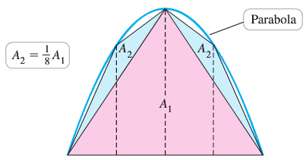***Solution***

At the n*th* stage, there are  triangles of area





So the total area of the triangles formed at the n*th* stage is



The total area under the parabola is







***Exercise***

1. Evalute the series 
2. For what values of a does the the series converge, and in those cases, what is its value?



***Solution***

1. 











This series telescopes to gives





1. 











This series telescopes to gives



 converges only iff 

Therefore, the series converges to:



***Exercise***

Suppose you borrow $20,000 for a new car at a monthly interest rate of 0.75%. If you make payments of $600/month, after how many months will the loan balance be zero? Estimate the answer by graphing the sequence of loan balances and then obtain an exact answer using infinite series.

***Solution***



Let  be the loan after *n* months.



 



 





 



















So the loan will be paid off after 39 months.

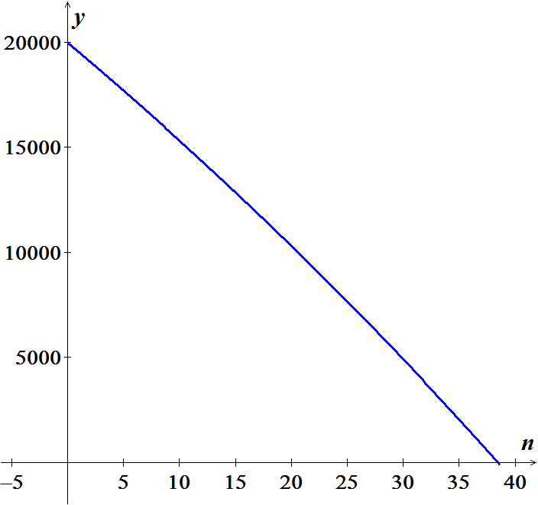

***Exercise***

An insulated windows consists of two parallel panes of glass with a small spacing between them. Suppose that each pane reflects a fraction *p* of the incoming light and transmits the remaining light. Considering all reflections of light between the panes, what fraction of the incoming light is ultimately transmitted by the windows? Assume the amount of incoming light is 1.

***Solution***

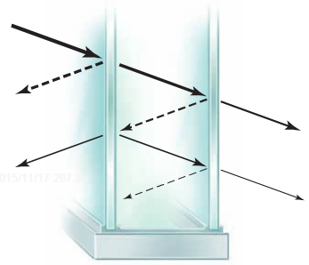Let  be the amount of light transmitted through the window the *nth* time the beam hits the second pane .

: is the reflection to the first pane.

: is the reflection back to the second pane.

Thus,



The amount of light transmitted through the windows the first time is 

Thus the total amount is:





***Exercise***

Suppose a rubber ball, when dropped from a given height, returns to a fraction *p* of that height. In the absence of air resistance, a ball dropped from a height *h* requires  seconds to fall to the ground, where  is the acceleration due to gravity. The time taken to bounce up to a given to fall from that height to the ground. How long does it take a ball dropped from 10 *m* to come to rest?

***Solution***

The height after the *nth* bounce is: .

The total time spent in that bounce is: 

The total time before the ball comes to rest:









***Exercise***

The fractal called the snowflake island (or Koch island) is constructed as flows: Let  be an equilateral triangle with sides of length 1. The figure  is obtained by replacing the middle third of each side of  with a new outward equilateral triangle with sides of length . The process is repeated where  is obtained by replacing the middle third of each side of with a new outward equilateral triangle with sides of length of . The limiting figure as  is called the snowflake island.

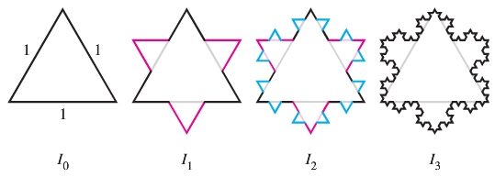

1. Let  be the perimeter of . Show that 
2. Let  be the area of . Find . It exists!

***Solution***

1. Triangle has 3 equal sizes, from  to  each side turn into 4, and so on.

 is obtained by  by dividing each edge into 3 equal parts, removing the middle part, and adding 2 parts equal to it. Thus 3 equal parts turn into 4, so 

This is a geometric series with a ratio greater than 1, so the *nth* term grows without bound.



1. From part (*a*)  has  sides of length ; each of those sides turns into an added triangle in  of sides length .

Thus the added area in  consists of  equilateral triangles with side .

The area of an equilateral triangle with side *x* is .

Thus 

















***Exercise***

Imagine a stack of hemispherical soap bubbles with decreasing radii  Let  be the distance between the diameters of bubble *n* and bubble , and let  be the total height of the stack with *n* bubbles.

1. Use the Pythagorean theorem to show that in a stack with *n* bubbles , , and so forth. Note that for the last bubble .
2. Use part (*a*) to show that the height of a stack with *n* bubbles is



1. The height of a stack of bubbles depends on how the radii decrease. Suppose that  where  is a fixed real number. In terms of *a*, find the height  of a stack with *n* bubbles.
2. Suppose the stack in part (*c*) is extended indefinitely . In terms of *a*, how high would the stack be?

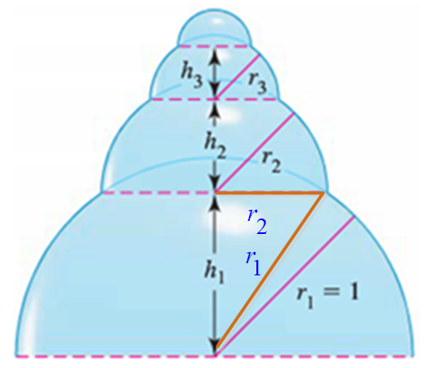***Solution***

1. Using the Pythagorean theorem; let :









1. Since 







1. ***Given***: 

 Since given 







 Since 

 

1.  







***Exercise***

The fractal called the *Sierpinski* *triangle* is the limit of a sequence of figures. Starting with the equilateral triangle with sides of length 1, an inverted equilateral triangle with sides of length  is removed. Then, the three inverted equilateral triangles with sides of length  are removed from this figure.

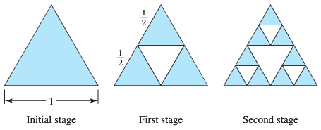

The process continues in this way. Let  be the total area of the removed triangles after stage *n* of the process. The area on equilateral triangle with side length *L* is .

1. Find  and  the total area of the removed triangles after stages 1 and 2, respectively.
2. Find  for 
3. Find 
4. What is the area of the original triangle that remains as ?

***Solution***

1. 









1. At stage *n*, there are  triangles of side length  are removed.

Each of those triangles has an area of 

Total 









1.  



1. The area of the triangle was originally , so none of the original area is left.

***Exercise***

The sides of a ***square*** are 16 *inches* in length. A new square is formed by connecting the midpoints of the sides of the original square, and two of the triangles outside the second square are shaded.

Determine the area of the shaded regions

1. When this process is continued five more times
2. 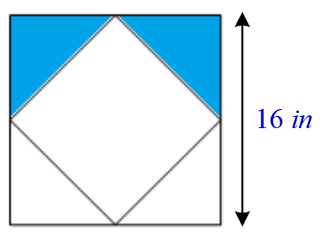When this pattern of shading is continued infinitely.

***Solution***

1. The first process: 



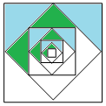 









1.  



***Exercise***

A right triangle *XYZ* is shown below where  and . Line segments are continually drawn to be perpendicular to the triangle.

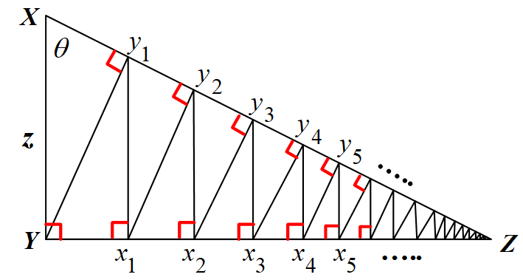

1. Find the total length of the perpendicular line segments  in terms of *z* and *θ*.
2. Find the total length of the perpendicular line segments when  and 

***Solution***

1. 





 

Total Length 

 



1. ***Given***:  and 

Total Length 





***Exercise***

The sphereflake is a computer−generated fractal that was created by Eric Haines. The radius of the large sphere is 1. To the large sphere, nine spheres of radius  are attached. To each of these, nine spheres of radius  are attached. This process is continued infinitely.

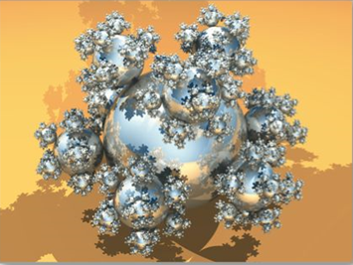

Prove that the sphereflake has an infinite surface area.

***Solution***

Surface area 



